**The Skill Gap: Approaches to Learning (ATL) Skills**

**Building Future-Ready Leaders who Learn “How to Learn”**

In a rapidly evolving world, education must extend beyond traditional subject knowledge. The International Baccalaureate (IB) curriculum at DYPIS, Worli does exactly this by emphasizing **Approaches to Learning (ATL) skills**, which empower students to become independent, reflective, and lifelong learners. These ATL skills form the backbone of the IB philosophy, helping students “learn how to learn” — a fundamental aspect of success in today’s world. The focus world over is to create leaders but learning ‘how to learn’ will mark one’s journey with passion, values and self-discovery. This is an essence for creation of visionary and ethical leaders of tomorrow.

**What Are ATL Skills?**

Approaches to Learning (ATL) skills are a set of essential skills grouped into five broad categories that transcend subject boundaries and empower learners to take ownership of their learning. These five skill clusters are:

1. **Thinking Skills**
2. **Communication Skills**
3. **Social Skills**
4. **Self-Management Skills**
5. **Research Skills**

These skills are not taught in isolation but are integrated into the teaching and learning process at DYPIS, Worli across all subjects, from the Primary Years Programme (PYP) to the Diploma Programme (DP) and Career related Programme (CP).

**1. Thinking Skills**

Thinking skills enable students to analyze, evaluate, and create. These include critical thinking, creative thinking, transfer, and reflection.

For example, in a PYP inquiry about the water cycle, students may be encouraged to design experiments, reflect on outcomes, and apply their understanding to different environmental scenarios. This nurtures problem-solving and innovation — key assets in any future career.

**2. Communication Skills**

Communication is more than just speaking. It includes listening, interpreting, reading, writing, and presenting ideas in a variety of forms.

In IB schools, students participate in discussions, collaborate on projects, and create presentations. Whether it's writing a persuasive essay in MYP- Middle Years Programme, English or giving a Theory of Knowledge (TOK) presentation in the DP, communication is vital for knowledge sharing and social development.

**3. Social Skills**

These skills focus on collaboration, empathy, and interpersonal relationships. In the IB classroom, students regularly work in teams, negotiate roles, resolve conflicts, and contribute to collective goals.

Group projects, service learning, and peer feedback mechanisms help students learn how to build positive relationships, navigate diversity, and function effectively in a community.

**4. Self-Management Skills**

This category includes both **affective skills** (such as resilience and emotional intelligence) and **organizational skills** (such as goal-setting, time management, and reflection).

Self-management is crucial in IB schools, where students often work on extended assignments and independent projects like the **Personal Project** (MYP- Middle Years Programme) or the **Extended Essay** (DP- Diploma Programme). These activities require students to plan their time, stay motivated, and overcome challenges — mirroring real-world professional tasks.

**5. Research Skills**

In our information-rich world, research skills are more important than ever. These include information literacy (finding, evaluating, and using sources) and media literacy (understanding and critiquing media).

Students use these skills to explore lines of inquiry, gather evidence, and construct reasoned arguments. Whether investigating global issues in Individuals & Societies or conducting experiments in Science, IB learners are trained to be curious, ethical researchers.

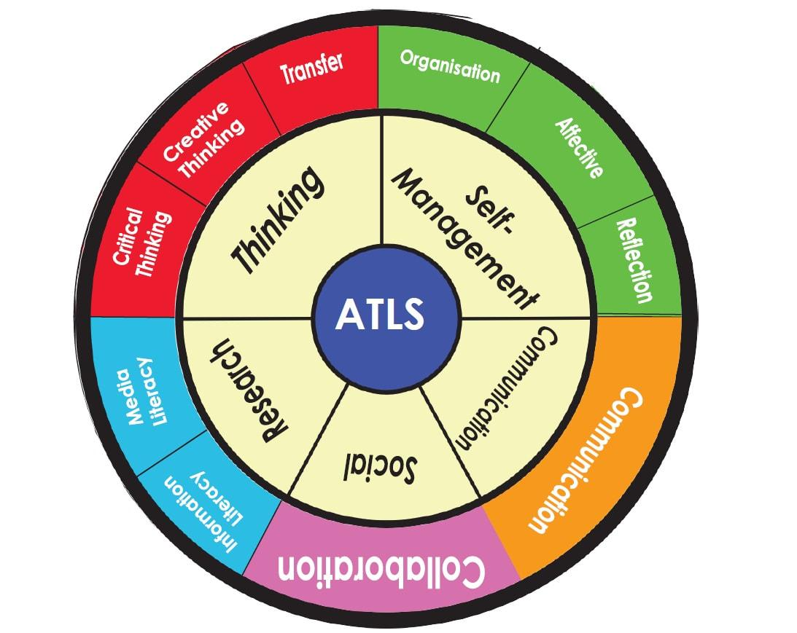

**Why ATL Skills Matter**

**1. Future-Ready Learners**

ATL skills are not just academic tools — they’re life skills. By mastering them, students are better prepared to adapt to new environments, learn continuously, and make meaningful contributions in any field. Employers increasingly value **soft skills** like collaboration, adaptability, and critical thinking — all nurtured through ATL.

**2. Personalized Learning**

One of the hallmarks of IB education at DYPIS, Worli is its emphasis on **student agency**. ATL skills empower learners to take control of their education by reflecting on their strengths, identifying areas for growth, and setting personal goals. Teachers use ATL to differentiate instruction, allowing students to progress at their own pace and according to their own learning styles.

**3. Cross-Curricular Relevance**

Unlike traditional models where subjects are siloed, we at DYPIS, Worli have an IB approach that uses ATL skills to weave subjects together. A student may use research and communication skills in both Science and Language classes, reinforcing learning and enhancing transferability.

**How DYPIS, Worli Implement ATL Skills**

**1. Planning and Integration**

Our teachers plan units with explicit ATL skill development in mind. For instance, while studying ecosystems, students may also be learning how to evaluate sources or collaborate effectively.

**2. Modeling and Scaffolding**

Our teachers model the use of ATL skills and provide structured support until students can apply them independently. Reflection journals, rubrics, and peer feedback are commonly used strategies.

**3. Reflection and Goal-Setting**

Students regularly reflect on their use of ATL skills and set new goals. This iterative process encourages self-awareness and a growth mindset — key traits of an IB learner.

| **Programme** | **Examples of ATL Skills in Action** |
| --- | --- |
| PYP | Reflective journaling, teamwork during inquiry |
| Cambridge Lower Secondary | Research during Global Perspectives Project, group debates. |
| DP and/or CP | Extended Essay research, TOK presentations, time management for IA deadlines |

**Conclusion**

Approaches to Learning (ATL) skills are a cornerstone of our IB education at DYPIS, Worli. We enable the students not just with knowledge, but with the tools to apply, adapt, and extend that knowledge in diverse contexts. Whether it’s learning how to manage time, think critically, collaborate with others, or communicate effectively, the students at DYPIS, Worli develop the confidence and competence to face future challenges with creativity and resilience. With Cambridge Education from Grade 6 to Grade 10, students also excel in the focused subjects of their choice. DYPIS, Worli creates a perfect blend of holistic skill based education with an expertise in subject knowledge thus widening the scope for the student to seek higher education in India or abroad. We at DYPIS, Worli nurture them to become global citizens and prepare them for life.